Far Eastern University – Institute of Technology

P. Paredes Street, Sampaloc, Manila 1015

CSSSPEC5 – Chapter 1

Submitted to:

Mr. Joferson L. Bombasi

Course Adviser

Submitted by:

Balboa, Jane P.

Faustino Jr., Arthur Y.

Laya, Jhance Bredh C.

Salazar, Angelica L.

N32

September 22, 2017

### **Introduction**

Money is one of the most fundamental invention of mankind (Ponnusamy, 2016), where all exchange happens with the involvement of this tool. Currency is thoroughly needed in the society, as all the economic activities such as production and distribution of goods are also involved with money. Additionally, money helps the human to monopolize its needs and grant every desire that are measured with monetary value. Thus, the economy is described as the money economy.

Counterfeiting of banknotes is one of the reason of the economy of every known country to be downsized. The issue has becoming prevalent in the Philippines, news after news of operations flashed on televisions of every Filipino citizens regarding operations of seizing this illegal activity (Ong, 2017). The counterfeiters have gained advantages through the development of technology as their methods of forging had evolved as well.

Each country tries to counterattack and end the problem, devices such as UV light Money checker which are available in banks and big local stores and Counterfeit Money Pens detector are invented (Deshmane, Gattani, Kadam , & Shirude, 2014). Nonetheless, these methods are inaccessible by the average citizens due to the devices being expensive. Additionally, developers from all over the world have tried to invent applications that would cater to the needs of average citizens.

The common features of these applications only involve one aspect of the banknote’s security feature. It may be through patches, color scheme or unseen marks or attributes present when the banknote is under the UV light. These characteristics, even though a dominant tool to help identifying what is real and fake when it comes to banknotes. Combining all these qualities would give a higher rate that the banknote detected is authentic.

The researchers have decided to develop a user-friendly android mobile application that will be able to detect the fake Philippine banknote from the genuine in terms of level one and level two security features, through the use of image processing algorithms.

### **Background of the Study**

The circulation of counterfeit money serves as a threat to national economies and to the welfare of average citizens. More specifically, these banknotes are used as a vital method of payment among local inhabitant (Poloz, 2016). As the practice of counterfeiting becomes more elaborate and refined as technology continues to evolve. The issue had become momentous, as the Philippine National Police authorities are applying the “last-touch policies” due to increase of number in counterfeiting money cases (De Jesus, 2014). The principle arises at the proliferation of criminal selling fake money have reached other regions in the Philippines.

According to Camus (2015), Smartphone market in the Philippines is at 40 percent by the year of 2015 but an influx in the industry will result in rise of 30 percent as the year of 2018 enters. It is due to the patronage of local vendors to the popular local retailer MyPhone, however popular retailers like Samsung and Asus have been battling with their pricing range with a sub-PHP 6k sector (Mendenilla, 2016). With the booming market of smartphone in the Philippines, it will effectively give a flexible range of choices in regards to the specifications and performance of smartphone.

Based on figure 1 from one of statistical analysis of Inquirer (2016), the usage of mobile among device users in the Philippines is much of a higher rate rather than the desktop that have never reached what the mobile usage had reached from years starting from 2011 up until 2016. Moreover, android is governing at a percentage of 81 percent over the Philippines mobile devices operating system, which is shown in Figure 2.

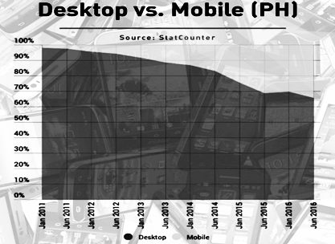

Figure 1. Desktop usage vs. mobile usage in the Philippines from 2011 to 2016

Android is an open source operating system that allows modification and customization of operating system in each phone. Mobile phones that have android operating system is often associated in the Philippine smartphone market as phones that are cost-efficient and have features that caters to the user’s demands. Thus, making the android platform as preferred platforms of Filipinos (shown in figure 2).

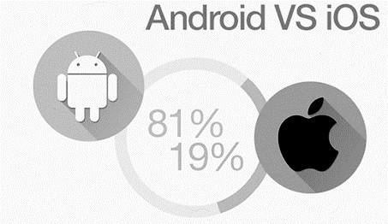

Figure 2. Percentage of operating system usage in the Philippines in year 2016

With this data, the researchers have devised a solution in the recurring problem of counterfeit banknotes by providing an application that runs on mobile, which is the preferred devices of Filipinos.

This study aims to develop a user-friendly mobile application that will detect counterfeit Philippine banknotes; with the aid of image processing algorithms. Furthermore, the application will provide a checklist for the features of level one and level two security of Philippine banknote. It will serve as a guide for the users to be aware of the security features of a banknote. The source of the visually recognizable security features will come from the Central Bank of the Philippines through an interview with the Deputy Director Currency Integrity Staff, Ms. Maja Gratia L. Malic.

### **Theoretical Framework**

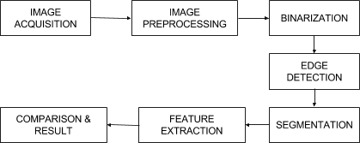

Figure 3. Wani and Sheetal’s Methodology Algorithm for Fake Indian Currency Recognition

In Wani and Sheetal’s (2016) research, the flow graph of the digital image processing they utilized is considered to be the commonly used methodology in recognizing counterfeit money. The first step is acquiring the image input which is a banknote, then it will be enhanced during the image preprocessing. Once the enhancement is done, the image will be converted into grayscale using binarization. This binarization is applied because it contains only the intensity information which is easy to process compared to RGB components. In converting the image into binarization, their application used advanced bitmap image processing technique. The next process is the most important algorithm in terms of banknote detection which is the edge detection. Edge detection aims to identify changes in brightness of the image or, more precisely, has discontinuities. The next phase is image segmentation; in this stage, the image is being segmented into various regions or objects. It is roughly based on two basic properties of image intensity values, either discontinuity or similarity. After segmentation, the next state is feature extraction. It is a special form of dimensionality reduction. In this phase, all the data from grayscale conversion, edge detection and segmentation will be processed. It comprises simplifying the amount of resources required to illustrate the abundant set of data. It determines domain specific attributes which are color, texture, and shape. It also categorized global attributes including moment variant, aspect ratio and circularity as well as the local attributes which contains boundary segment. Finally, the comparison and results where all the extracted features will be matched with the authentic banknote. If it matches, it will then determine that the banknote is genuine, otherwise counterfeit (see figure 3).

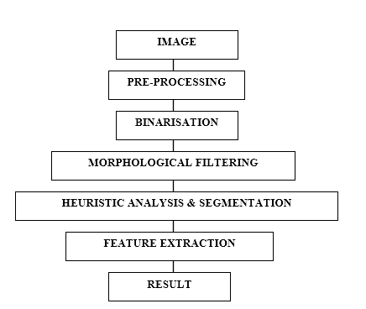

Figure 4. Reel, Krishan, and Kotwal’s Proposed Approach using Morphological Filtering and Heuristic Analysis

In the study by Reel et al. (2011), their system is designed with the aid of MATLAB; using the image processing toolbox. The first three phases are the same as the process used in Wani and Sheetal’s study. The binarization in this proposed approach is implemented using the concept of thresholding; wherein an individual pixel in an image is marked as “object” pixels if their value is greater than the background’s threshold value, otherwise as “background” pixels; considering that the object is brighter than the background. This principle is known as threshold above. Another possibility is threshold below which is the reverse of threshold above. The next phase is called morphological filtering which refers to the process of removing further noise and unexpected edges on the serial numbers of the banknote. To remove the noise, they applied the four binary processing functions such as erosion, dilation, opening and closing. Following is the highlight of this approach which is the heuristic analysis, wherein the analysis concentrates with the statistics of brightness and the contrast of segmented characters. The heuristic analysis enhanced the recognition process by separating character and non-character elements based on the color. If the image is represented in Hue Saturation Value (HSV), the segments can be computed directly its global hue saturation which will serve as the mean of hue and saturation of individual pixels. Once the image is in RGB model, it should be transformed to its HSV model first. The following are the formulas for the individual properties of a character. After performing the statistical formulas which are used is segmenting the serial numbers of a banknote, the next stage is the feature extraction. Features in this approach are categorized in structural features, statistical features and global transformation. Finally, the result.

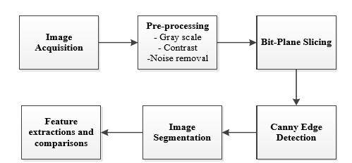

Figure 5. Alshayeji et. al’s Block Diagram using Bit-plane slicing and Canny Edge Detection

### **Conceptual Framework**

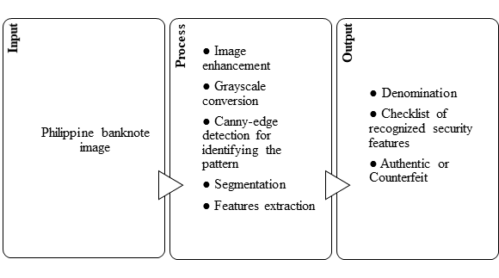

Figure 6. Input – Process – Output of the System

**Input.** The user must input an image of Philippine banknote by means of capturing directly using mobile built-in camera or selecting from his/her gallery. The captured image should not be blurred otherwise, the program will ask the user again to recapture the banknote.

**Process.**

**Output.** Once the process completed, the system will provide the result if the money is genuine or fake. It will also identify the denomination of the input banknote and generate a checklist of the recognized security features.

### **Objectives of the Study**

The study aims to design and develop an android mobile application that will assess the credibility of a banknote according to the levels of security of the latest Philippine banknotes; through image processing using OpenCV library.

Specifically, the study aims the following.

* To provide an app that can capture selected Philippine banknote using android mobile built-in camera.
* To utilize Optical Character Recognition (OCR) in determining the denomination of a Philippine banknote.
* To distinguish selected genuine Philippine banknote from a counterfeit one through identifying the pattern extraction from watermark and micro-printing using Canny edge detection and Hue Saturation Value (HSV).
* To stipulate a checklist of recognized security features with the aid of feature extraction via image segmentation, Canny-edge detection and Support Vector Machine (SVM).

### **Scope and Limitations**

The study focuses solely on developing an android mobile application which can assist the people who utilizes Philippine banknote in recognizing the security features of 500-peso bill and 1000-peso bill. The application solves the widespread problem of distinguishing counterfeit Philippine banknote from the genuine. It allows the users to capture Philippine banknote which the users want to verify using the mobile built-in camera. The user can also select an image from his/her mobile gallery. It will then generate a checklist of security features; to serve as a guide for the users to be aware of the banknote’s security features and determine if the banknote is authentic or counterfeit.

The researchers will employ Android Studio IDE as a tool in developing the application and will utilize the OpenCV library as a source of the image processing algorithms. The application will be available for android users only. A mobile camera with 8 MP is the minimum quality supported by the application. The banknote must not have any ink or scratch, otherwise, it will not be recognized properly. The acknowledged banknote that will be processed is limited to the signed banknotes of President Rodrigo Roa Duterte only.